

Clinical Investigation

Program Handbook

2026-2027
Institute for Clinical and Translational Research
Consult this handbook to learn about program-specific information, procedures and resources for graduate students in the Clinical Investigation

Last updated: August 2026

Welcome
Welcome to the Clinical Investigation Graduate Program at the University of Wisconsin–Madison's Institute for Clinical and Translational Research (ICTR).

Clinical Investigation is a field that brings together biomedical researchers, health care professionals, community partners, and other collaborators to develop, design, and conduct research that improves health for people and animals. The goal is to turn scientific discoveries into practical solutions that can be used in real-world patient care.

Translational science focuses on finding new and better ways to move research from the laboratory to patients by overcoming common challenges that can slow progress. Our program is also committed to advancing health equity and reducing health disparities.

By working together to improve health, we embrace the spirit of the Wisconsin Idea—the belief that the benefits of the University should reach every family in Wisconsin and beyond, as expressed by UW President Charles Van Hise in 1905.

Table of Contents
Welcome i
Table of Contents ii
Navigating Policy and Resources at UW-Madison 1
Graduate Program Managers 2
Director of Graduate Studies 2
Faculty Advisor 2
Graduate School Services 2
Department and Program Overview 3
In Our Program/Department 4
On Campus and In the Community 4
Getting Started as a Graduate Student 5
New Graduate Student Checklist 5
Graduate Student Portal 5
Advising and Mentoring 5
Advising Compact 6
Changing Your Advisor 8
A Graduate Student Guide to Working with Faculty Advisors 9
Mentoring Networks 9
Degree Requirements 10
Master’s Degree 10
Requirements 10
Thesis 10
Doctoral Degree 14
Requirements 14
Committee 14
Preliminary Exam 15
Dissertation and Final Oral Exam/Defense 17
Doctoral Degree Checklist: Timeline and Deadlines 19
Minor in Clinical Investigation 19
MSTP MD/PhD 19
Academic Policies 20
Enrollment Requirements 20
Academic Exception Petitions 20
Progress Towards Your Degree 21
Satisfactory Academic Progress (SAP) 21
Not Meeting Academic Expectations 22
Grievances and Appeals 23
Personal Conduct Expectations 24
Professional Conduct 24
Academic Misconduct 24
Non-Academic Misconduct 24
Research Misconduct 25
Hostile and Intimidating Behavior (Bullying) 25
Reporting Incidents (Harassment, Discrimination and Bias, Hostile and Intimidating Behavior, Sexual Harassment, Sexual Assault, Dating and Domestic Violence, and Stalking) 25
Funding Information and Resources 26
Finding Funding Without a Guaranteed Appointment 26
Campus-Wide and External Sources 26
Additional Policies and Resources 27
Professional Development 27
On Campus 27
Individual Development Plan (IDP) 27
DiscoverPD 27
Graduate Career Compass 28
Free Career- and Skill-Building Memberships 28
Delta Program in Research, Teaching, and Learning 29
GradConnections 29
Additional Resources 30
McBurney Disability Resource Center 30
Office of Student Assistance and Support (OSAS) 30
University Health Services (UHS) 30
UWill 30
Let’s Talk 30

Navigating Policy and Resources at UW-Madison
This handbook shares important information specific to your degree program. Refer to it as you become familiar with the policies, procedures, requirements, and resources of graduate education at UW-Madison.
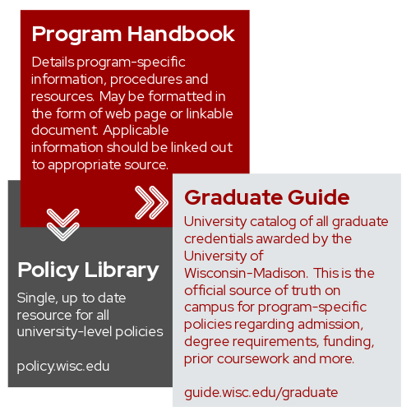
Clinical Investigation Graduate Program
Graduate Guide
UW-Madison Policy Library
Resources and information curated by the Graduate School for prospective and current students are found the Graduate School website. The Graduate Student Life website is also maintained by the Graduate School and provides useful information for new graduate students.

Graduate Program Managers
Beth Bierman  bbierman@wisc.edu  608-262-3768  2111J Health Sciences Learning Center (HSLC) | Deidre Vincevineus  vincevineus@wisc.edu  608-26-3274  2111J Health Sciences Learning Center (HSLC)

Director of Graduate Studies
Lisa Cadmus-Bertram, PhD
lisa.bertram@wisc.edu
608-265-5946
297 Medical Sciences

Grievance Advisor
Ron Gangnon, PhD
ronald@biostat.wisc.edu
608-265-0688
703 WARF Office Building

Faculty Advisor
The name and contact information of your faculty advisor is listed on your Student Center on MyUW under “Academic Progress” and then “Advisors.”

Graduate School Services
The Graduate School is available for general inquiries. The contact information for the appropriate office is found on the Graduate School’s website.

Department and Program Overview
Clinical Investigation Overview in Guide

How to Get Involved

As a graduate student at UW-Madison, you have a multitude of opportunities to become involved on campus and in your academic discipline. This involvement often enhances your academic, professional, and personal growth through developing advanced leadership, communication, and collaboration skills. It also provides an opportunity for professional networking.

Belonging and Inclusion

We welcome and seek a diverse student body, and we uphold the university’s equal opportunity and affirmative action policy. We work in partnership with the Graduate School’s Office of Access, Engagement and Funding We also work in partnership with the McBurney Disability Resource Center to help create an accessible and inclusive educational experience for students.

In Our Discipline

ICTR is the administrative home for the MS and PhD degree programs in Clinical Investigation. Clinical Investigation is governed jointly by representatives of ICTR’s academic partners: Schools of Medicine and Public Health, Nursing, Pharmacy, Veterinary Medicine, College of Engineering, School of Education, and Marshfield Clinic. Faculty members from each academic partner serve as instructors, mentors, and leaders to strengthen Clinical Investigation’s training with multidisciplinary clinical-research knowledge and skills as they develop into independent clinical-research scientists.

In Our Program/Department
Executive Committee (EC): Comprised of faculty members from partner schools/colleges/health systems, the EC has the authority to establish degree requirements beyond the minimum required by the Graduate School, approve policies described in the Clinical Investigation Handbook. Faculty are appointed to renewable 3-year terms.
Admission Subcommittee (AC): Makes final decisions on admission to the Clinical Investigation MS and PhD programs for fall and spring admission. Faculty are appointed to renewable 3-year terms.

Curriculum Subcommittee (CC): Reviews and makes recommendations to the EC about curricular changes, additions, and omissions and considers and approves course waiver requests for specialized independent study. Faculty are appointed to renewable 3-year terms.
Clinical Investigation periodically will request volunteers to represent students as non-voting (advisory) curriculum subcommittee members. Membership ends with MS thesis or PhD dissertation defense.

On Campus and In the Community
The Wisconsin Idea is the principle that education should influence and improve people’s lives beyond the university classroom. For more than 100 years, this idea has guided the university’s work.
You will find ways to engage in campus and local community life at: Graduate School: Support for Your Wellbeing.
The Graduate School Office of Access, Engagement and Funding supports students from an array of life experience and backgrounds. This office helps students build a sense of belonging on campus. You can read more about participating in events hosted by the Graduate School at: Graduate School: Community and Belonging.
If you are a student actively involved in leadership and service activities, consider nominating yourself for membership in the following honor society: Edward A. Bouchet Graduate Honor Society.

Getting Started as a Graduate Student
This section guides you through important steps to take as you begin your journey as a graduate student at UW-Madison.

New Graduate Student Checklist
The Graduate School’s "New Students" page has useful information, including the new graduate student checklist. The checklist also links to additional resources for new international students, students with disabilities, student veterans, and students with children: Graduate School: New Graduate Student Checklist.

Graduate Student Portal
The Graduate Student Portal allows you to complete actions related to your graduate program as well as other resources. You should become familiar with this site as you navigate graduate education. You can also complete the following through this page:
- Submit add/change/discontinuation requests for any major/named option, doctoral minor or graduate/professional certificate;
- View status of degree completion warrants;
- Discover professional development opportunities;
- Submit payment for completion of your doctoral dissertation; and more.

Advising and Mentoring

Advising relationships are a central part of academia, important to both the experience and development of students and faculty members alike.

The Graduate School’s definition of an advisor can be found in the Graduate School: Advisor policy.

Clinical Investigation advisors are expected to mentor students in the program either as advisors or as members of dissertation committees. Advisors are also expected, when called upon, to serve as members of the admissions, curriculum, and/or executive committee.

The advisor has two main roles: 1) to assist the student in acquiring the highest possible level of knowledge and competence in the field, and 2) to help the student convene the committee that will determine whether the student has performed at an acceptable level in each degree milestone. Additional roles for the advisor include tracking student’s degree process, assisting with course selection and planning the student’s academic path, and helping them identify additional possible research mentors and research opportunities.

As the advisor-student relationship is one of mutual agreement, it may be terminated by either party. If the student would prefer collaborating with a different advisor, the student should discuss this with the new prospective advisor to seek the change. If you change your advisor, you must notify your Graduate Program Coordinator and follow any related procedures.

Students are required to meet with their advisor annually and complete the “Annual Student Progress Form” during the spring term. This form will be sent to individual students in the spring term by the Graduate Program Manager. Failure to return this completed form will result in an academic hold being placed on the student’s record.

Advising Compact
Dissertation/Thesis Committee

Responsibilities of the Dissertation/Thesis Committee:
- Advocate for the student’s success by being available to discuss issues of important, including the thesis project, career planning, and equity.
- Meet annually with the student to provide critical evaluation of the student’s scientific progress, in regard to the Clinical Investigation (CI) learning goals. It is the student’s responsibility to arrange the Dissertation/Thesis Committee meetings.
- Provide feedback to the student and dissertation/Thesis Advisor regarding the feasibility of research goals and plans.
- Encourage on-going training in responsible conduct of research and experimental design, as it related to ethical considerations, rigor, and reproducibility.
- Support the student’s professional development, using the student’s individual Development Plan (IDP) or Annual Student Profess Report as a point of discussion.
- Step in should disagreements arise between the student and Dissertation/Thesis Advisor or if other issues arise that impede progress toward the degree. Communicate serious issues with the CI Program Director.
- In consultation with the student and Dissertation/Thesis Advisor, set objectives that need to be met for a student to defend. Objectives could include completing particular experiments and publishing the findings. The CI Program does not require publications, but for career advancement it is in the student’s best interests to publish their work prior to defending their Dissertation/Thesis.
- At the end of every Dissertation/Thesis committee meeting, the student will leave the room, and the committee will discuss what the student needs to do over the coming year. When the student returns to the room, a member of the Dissertation/Thesis committee other than the Dissertation/Thesis advisor should summarize the discussion. It is good practice to do this at every meeting, even if the student is doing well.
- Additionally, at each Dissertation/Thesis committee meeting, in line with best practices, the thesis mentor will leave the room, allowing the thesis committee and the student to collaboratively explore avenues for the advisor’s mentorship development. The resultant advice should be communicated to the advisor post-meeting by a committee member.

Advisor Responsibilities:
- Encourages the student to be independent in terms of scientific thought and process.
- It is supportive, accessible, encouraging, respectful, and fosters open communication.
- Ensures that the research environment is safe, equitable, and free from harassment and discrimination.
- Models ethical behavior and discusses ethical approaches in conducting the research.
- Communicates expectations regarding work habits and behavior in the laboratory.
- Works closely with the student to design a meaningful thesis project.
- Provides consistent and constructive feedback about laboratory skills, writing, and presentations, and being honest when performance does not meet expectations.
- Encourage student presentations at local, national, and international conferences.
- Acknowledges student contributions.
- Facilitates timely publication of student research.
- Pursues opportunities to secure resources necessary to provide stable financial support.
- Prepares the student for their chosen career path by discussing goals and plans for achieving them.
- Consults with the student in identifying a position upon graduation and provides letters of recommendation that convey the student’s experience and accomplishments.

Student Responsibilities:
- Pursues scientific goals with intensity, motivation and creativity, working with integrity in all aspects of graduate training.
- Takes ownership of their training, with guidance from the advisor and committee.
- Reads relevant scientific literature.
- Thinks intentionally and often about short-, mid-, and long-term training and development goals.
- Meets regularly with the advisor to provide updates on the results of activities, experiments, and progress in general.
- Initiates meetings on a regular basis with their committee and will initiate meetings as needed or desired with members of the committee individually for guidance regarding research and professional activities.
- Attends and participants in laboratory meetings, and recognizes that seminars, journal clubs, and other professional activities encouraged or required by the advisor and committee are important to training.
- Complies with all institutional policies, including safe laboratory practices, responsible conduct of research, experimental design and transparency as it relates to reproducibility and individual development plans.
- Discusses policies on work hours, sick leave, and vacation with the Thesis Advisor.
- Takes ownership of professional development, through completion of an IDP annually and with guidance from the advisor and committee.

Changing Your Advisor
The Graduate School requires a student to have an advisor. The Graduate School: Advisor policy explains the consequences of not having an advisor as well as the possibility of having a co-advisor. The official record of your advisor is located on the Student Center on MyUW under “Academic Progress” and then “Advisors.” Discuss an advisor change with your prospective advisor to seek the change and connect with your graduate program/manager for the appropriate procedures.

As the advisor-student relationship is one of mutual agreement, it may be terminated by either party. If you decide that you would prefer working with a different advisor, discuss this with your prospective advisor to seek the change.

If you change your advisor, you must notify your Graduate Program Coordinator and follow any related procedures.

Every graduate student must have an advisor or else they may be suspended from graduate study at UW-Madison by the Graduate School. Be sure to follow procedures to re-select a new advisor (described above) prior to finalizing the termination of your current advising relationship. You can confirm that the name of your advisor has been updated in the official record by looking in your Student Center on MyUW under “Academic Progress” and then “Advisors.”

A Graduate Student Guide to Working with Faculty Advisors
Through this interactive, self-paced micro-course, graduate students learn about the characteristics of functional and dysfunctional relationships with advisors, strategies for communicating effectively and aligning expectations, as well as program grievance processes and Hostile and Intimidating Behavior resources. Completing the micro-course takes about 20 minutes and is optional but encouraged for all graduate students.

Mentoring Networks
The Center for Teaching, Learning and Mentoring is one of several centers of excellence for research mentor training on campus.
In addition to your formal advisor, you are encouraged to develop a broad network of individuals who can provide academic and professional mentorship during and beyond your time as a graduate student.

Degree Requirements

Master’s Degree
All students in the Clinical Investigation Master’s Program are responsible for staying informed of the following requirements to earn the degree.

Requirements
For all current requirements to earn your degree (e.g., minimum credit requirement, required courses, non-curricular milestones, learning outcomes/goals, etc.) see your program’s page in the Graduate Guide. Navigate to Clinical Investigation MS Degree Requirements, which contains all official requirements for your degree in the current year. Similarly, see “Policies” from the navigation bar of your program’s page to learn about major-specific policies affecting these requirements (e.g., prior coursework, probation, credits per term allowed, time limits, grievances and appeals, etc.). When you look at the Guide to learn about program requirements, you are viewing the current year’s version. To find past versions of program requirements, see the Guide Archive and search for your program and the year you would like to reference.

Thesis

Committee and Topic
Master’s committees advise and evaluate satisfactory progress, evaluate a thesis, and/or sign a degree warrant. For general guidance from the Graduate School on the role and composition of committees as well as an online tool to determine if your committee meets minimum requirements, see the Graduate School: Committees (Doctoral/Master’s/MFA) policy. In addition to this general guidance, this program requires the following of master’s committees:
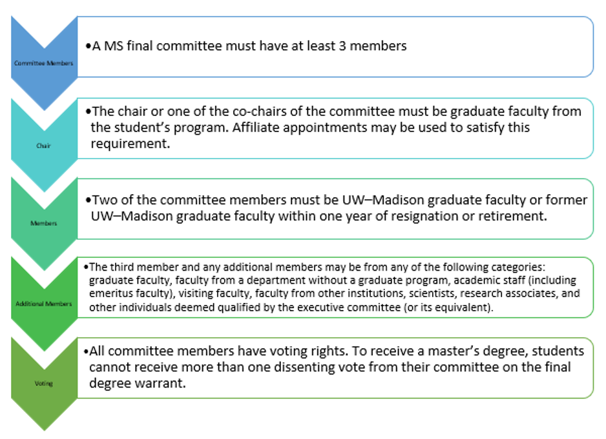
Your advisor chairs your committee and provides individualized guidance on how to select committee members.

Form and Content

The MS thesis comprises a technical report or a traditional thesis on the project approved by the student’s 3-member MS committee. To fulfill this requirement, students complete an independent research project and write and defend this work with their 3-member MS committee.

A technical report addresses a scientific problem or project of a substantial nature. The general requirement for the report is that it treats some significant scientific problem or project in sufficient depth to contribute to clinical or translational knowledge. The technical report should be conducted and prepared in a manner suitable for publication in a national academic journal. A publishable/published descriptive literature review by itself is not adequate to fulfill this requirement.

A traditional thesis involves more substantial research than a technical report. Students prepare their thesis or technical report using the guidelines for writing a scientific report available in the UW Writing Center handbook (https://writing.wisc.edu/handbook/). Briefly, a scientific report includes six basic elements: title, abstract, introduction, methods, results, and discussion. (https://grad.wisc.edu/current-students/masters-guide/).

Formatting requirements for completing your thesis, Guide to Preparing Your Master's Thesis

Procedures
After completing all degree requirements, students are responsible for scheduling their final MS Thesis Defense. The student’s advisor and committee members must attend. In addition, students must their request final MS degree warrant at least 3-weeks prior to their scheduled MS defense by completing this online warrant request: https://uwmadison.box.com/s/b2ph0gfv8e0ezpmenn4fgt1c1fmhtokd.

During the MS Thesis Defense, the student’s advisor is responsible for leading the thesis defense and supporting the student throughout the process. The MS Thesis Defense will typically last about 2 hours. The advisor will begin by asking the student to provide a brief background for the committee (i.e., BS degree, professional degree, work experience, and how you got interested in your research topic). The oral presentation should be concise and factual. The introduction and review should be brief, and presentation should emphasize research methods and results. The committee is primarily interested in the student’s own work. Questions by the committee during the presentation are for clarification purposes only. The oral presentation might be “open” to the public.

Following the formal presentation, committee members will ask extensive questions referring to specific parts of the thesis and oral presentation. The major advisor functions as the moderator and every committee member will be allowed sufficient time to question the student.

Next, the student will be asked to briefly summarize the most important new findings of your thesis research, and you will be asked to leave the room. The committee will focus on evaluating the student’s thesis research, defense, and overall record in a private closed-door session. There should be time for the committee to consider each of these items, and, if necessary, to formulate instructions to be implemented by advisor. The committee will pay particular attention to whether the student’s own contributions are clearly delineated and thoroughly documented in the thesis. At the conclusion of this private closed-door session, the committee will decide whether the student has passed or failed the thesis defense and subsequent efforts that must be undertaken by the student to complete their degree requirements. Finally, the student will be invited to rejoin the meeting and the advisor will let the student know the outcome. It is important that the advisor keep track of verbal comments. Any committee member that requires a change before they sign the warrant must make that requirement clear.

Clinical Investigation does not require the MS Thesis to be deposited into the library.

Doctoral Degree
All students in the Clinical Investigation Doctoral Program are responsible for staying informed of the following requirements to earn the degree.

Requirements
For all current requirements to earn your degree (e.g., minimum credit requirement, required courses, non-curricular milestones, and learning outcomes/goals, etc.) see Clinical Investigation PhD Degree Requirements., which contains all official requirements for your degree. Similarly, see “Policies” from the navigation bar of your program’s page to learn about major-specific policies affecting these requirements (e.g., prior coursework, probation, credits per term allowed, time limits, grievances and appeals, etc.). When you look at the Guide to learn about program requirements, you are viewing the current year’s version. To find past versions of program requirements, see the Guide Archive and search for your program and the year you would like to reference.

Committee
Doctoral committees advise and evaluate satisfactory progress, administer preliminary and final oral examinations, evaluate a thesis or dissertation, and/or sign a degree warrant. For general guidance from the Graduate School on the role and composition of committees as well as an online tool to determine if your committee meets minimum requirements, see the Graduate School: Committees (Doctoral/Master’s/MFA) policy. In addition to this general guidance, this program requires the following of doctoral committees:

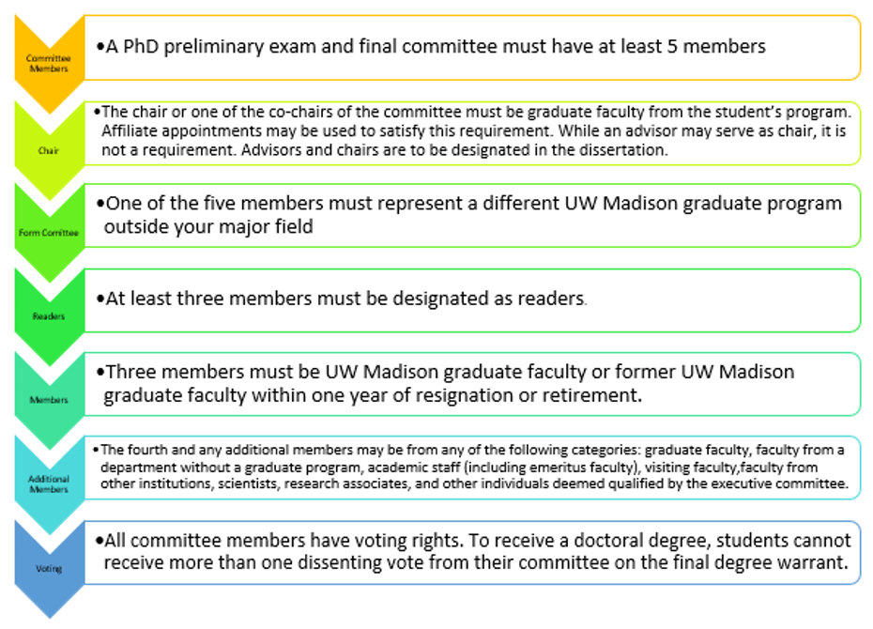
Your advisor chairs your committee and provides individualized guidance on how to select committee members.

Preliminary Exam
The preliminary examination (prelim) consists of a written research proposal and oral presentation. Students are expected to have completed required coursework and at least 35 credits prior to scheduling their preliminary examination. The prelim is a comprehensive assessment of a student’s knowledge and skills acquired through the graduate curriculum and abilities to apply clinical and translational research concepts to a field of study. Clinical Investigation encourages students to meet with their advisor when preparing for the preliminary examination. To review the Graduate School’s preliminary examination requirements and deadlines: https://grad.wisc.edu/current-students/doctoral-guide/#complete-your-preliminary- examinations.

The written research proposal subject matter will align with the student’s anticipated dissertation research and is a comprehensive assessment of the student’s knowledge and skills acquired through the graduate curriculum and abilities to apply clinical and translational research concepts to a field of study. The primary objectives of the preliminary exam are to:
- Determine whether the student can independently identify an important and novel scientific problem and provide feasible step by step research strategies to address the problem;
- Assess the student’s ability to recognize barriers in the long-range planning of a research proposal and present methods of adaptation to overcome such barriers;
- Determine whether the student can develop a logical approach to a specific problem (i.e., which experiment comes first, second, etc..) or research question and gauge the anticipated timeline for the proposed research project;
- Determine whether the student can present the proposal with clarity in written and oral form; and
- Determine whether the student can defend the proposal and effectively respond to criticism and questions.

Students submit the written proposal to the degree committee at least two weeks prior to the oral exam. Students may use an NIH-style grant proposal for their prelim exam. The program recommends an approximate length for the written proposal at 30 pages using 12-point double-spaced type. This excludes tables, figures, appendices, and references.

The program suggests allotting two hours for the oral preliminary presentation and examination. This consists of an oral presentation (30-40 minutes in length) and a defense of the student’s written proposal describing the research planned as a basis for the PhD dissertation. The oral presentation is made to the student’s committee which includes five graduate faculty members, at least two of who are from Clinical Investigation faculty, including the student’s advisor. After the examination, the committee will reach consensus on the student’s performance and readiness for dissertator status.

The student is examined on details of the proposed work as well as on the underlying principles and concepts of the field. This written proposal or oral presentation should not be approached as draft documents. The committee will evaluate the student’s research proposal on originality, appropriateness of methods and design, and clarity of presentation. The written proposal and oral presentation should demonstrate proficiency in conducting independent research.

Preliminary exam outcomes including passing, written revisions only, written revisions and new oral proposal examination, and fail. If the student passes their preliminary exam, their committee signs the preliminary warrant. If the student’s committee requires written revisions, the committee notifies the Graduate Program Manager of this requirement and once those revisions have been made by the student. The signed prelim warrant will be submitted to the Graduate School after confirming that satisfactory revisions have been made. If the student is required to submit written revisions and repeat of the oral proposal examination, the student is required to notify the Graduate Program Manager and reschedule a new preliminary exam date. If the student fails their preliminary exam, the student discusses the committee’s recommendations with the Graduate Program Manager and what next steps are available. If the preliminary exam is not successfully completed, students cannot continue in the Clinical Investigation PhD program.

Students advance to dissertator status and become PhD candidates after completing all requirements for the PhD and passing the preliminary exam. Dissertators must enroll in 3 credits of research per term (e.g., MED 990).

Dissertation and Final Oral Exam/Defense

Topic
Your advisor can provide guidance on selecting your dissertation topic. Note that your committee composition may or may not need to change as well in this scenario, depending upon your new advisor’s guidance.

Form and Content
A student’s dissertation research project (topic) is a written report of the student’s original contribution to scientific literature that was proposed in the oral preliminary exam and approved of by student’s committee. The dissertation must be prepared according to Graduate School standards (https://grad.wisc.edu/current-students/doctoral-guide/). The Graduate School provides dissertation support (https://grad.wisc.edu/current-students/dissertation/).

Students formally notify Clinical Investigation of their plan to defend their dissertation and graduate by completing a final warrant request (https://uwmadison.box.com/s/b2ph0gfv8e0ezpmenn4fgt1c1fmhtokd). The Graduate School requires that a student’s warrant request be submitted 3 weeks prior to the student’s schedule defense date. The student should submit their completed dissertation to their committee at least 4 weeks prior to their scheduled defense, or as allowed by their committee.

A student, in consultation with their advisor, should choose one of the following two formats to write their dissertation, a traditional format or a 3-paper research format.

- A technical report addresses a scientific problem or project of a substantial nature. The general requirement for the report is that it treats some significant scientific problem or project in sufficient depth to contribute to clinical or translational knowledge. The technical report should be conducted and prepared in a manner suitable for publication in a national academic journal. A publishable/published descriptive literature review by itself is not adequate to fulfill this requirement.

- A traditional thesis involves more substantial research than a technical report. Students prepare their thesis or technical report using the guidelines for writing a scientific report available in the UW Writing Center handbook (https://writing.wisc.edu/handbook/). Briefly, a scientific report includes six basic elements: title, abstract, introduction, methods, results, and discussion. (https://grad.wisc.edu/current-students/masters-guide/).

Procedures
The dissertation manuscript should be appropriate for publication in peer reviewed national or international journals. The manuscript should be ready for submission (or previously submitted) and follow the formats of the journals chosen by the student and advisor. The appendix must demonstrate the full development of the dissertation material and is constructed based on the guidance of the advisor and committee.

The program suggests allotting two hours for the student’s oral defense presentation and final examination. This consists of an oral presentation (30-40 minutes) and a defense of the student’s dissertation. Following the examination, the student’s committee will meet for an executive session. To pass the final examination, the student must receive no more than one dissenting vote from their committee. A missing signature is considered a dissent.

Once the final warrant has been signed, it is submitted to the Graduate School. The student is required to upload a signed copy when submitting their final/corrected dissertation to ProQuest and complete their exit interviews. The student should review the Graduate School’s degree conferral (https://grad.wisc.edu/documents/degree-conferral-payroll-end-dates/) and dissertation deposit deadlines (https://grad.wisc.edu/deadlines/).

Doctoral Degree Checklist: Timeline and Deadlines
The Graduate School maintains a list of steps to complete your doctoral degree, including deadlines and important things to know as you progress toward graduation. In addition to what is posted on the webpage from the Graduate School, you must meet all required steps of the program.

Minor in Clinical Investigation

PhD students in other disciplines may want to complete a minor in Clinical Investigation as a way to learn about applications of science to clinical disciplines (https://ictr.wisc.edu/program/graduate-program-in-clinical-investigation/ and https://guide.wisc.edu/graduate/institute-clinical-translational-research/clinical-investigation- doctoral-minor/#requirementstext).

MSTP MD/PhD

Starting in 2023, Clinical Investigation and the Medical Scientist Training Program (MSTP) joined to combine clinical medicine with graduate training in Clinical Investigation. Through team-research experience and coursework, MSTP students gain exposure to faculty from a variety of scientific disciplines to prepare them to direct or contribute to patient-oriented clinical research teams.

The MD/PhD Program’s goal is to create a combined physician and clinical investigator who will make major contributions to human health. The PhD in Clinical Investigation is an applied degree in which students focus on the creation of novel methodologies and tools for translational science within the context of a specific biomedical discipline.

At the completion of the MD/PhD Program, students leave with an MD/PhD degree. MD/PhD students complete 2.5 years of Medical School and then begin their PhD training in Clinical Investigation.

MD/PhD students apply to change from the Cellular and Molecular Biology Graduate Program (CMB) to the Clinical Investigation by October 1st of Fall M3 of “Phase 2: Clinical Rotations” (https://grad.wisc.edu/documents/change-program/) via their Graduate Student Portal (in the MyGradPortal in MyUW).

Academic Policies

Enrollment Requirements
The Graduate School maintains the official academic and administrative policies relevant to graduate students.
The Graduate School’s Academics page provides important information related to academic matters, policies and academic success. The following links have important information relevant to courses and enrollment that is important for you to be aware of:
- Enrollment Requirements
- Late Enrollment, Course Change, or Drop
- Other Types of Courses
- Cancel or Withdraw Enrollment

Academic Exception Petitions
Course Waiver Request are initially reviewed by the Graduate Program Director and subsequently discussed at the Curriculum Subcommittee's semi-annual meetings. Requests must be submitted to the Graduate Program Manager prior to the scheduled semi-annual meeting for review. Following review and committee discussion, waiver requests will be approved or denied in a timely manner.

Students may qualify for Course Waivers if they demonstrate subject matter competency for certain courses in the curricula. A student’s Course Waivers may be exempt from up to (6) units of study, if approved. If a student is granted a Course Waiver, they must satisfy the unit requirement by identifying and completing courses, with the approval of their program director or advisor (e.g., enrolling in additional MED 990-research credits to fulfill the Graduate School’s degree credit minimum).
To determine your eligibility for a Course Waiver, we ask that you submit specific details for evaluation. Your request should present significant academic experiences, which have prepared you to meet most of the course objectives, concepts, and learning outcomes stated in the course description for the program course that you wish to waive.

Submit the following to request a Course Waiver Request:
- A completed and signed Course Waiver Form (request this form the Graduate Program Manager).
- Transcript(s) from your previous institutions (if not submitted with UW graduate application materials).
- Official syllabus, or course description per course.

Here is an overview of the evaluation parameters:
- Demonstration of academic or professional work that has direct equivalency to an approved program requirement.
- Course completed at an accredited higher education institution, with a grade of B or better.
- Course currency demonstrated by taking the course during the last two (2) years. Exceptions to the 2-year limit are made at the discretion of the Graduate Program Director.

Keep in mind that some academic exceptions may need to be approved by the Graduate School. For further information about this, contact the Director of Academic Services.

Progress Towards Your Degree
The Graduate School provides relevant information you should be aware of as you progress towards your degree. Students must follow Graduate School policies, program-specific policies and if applicable, employment policies. Programs are required to provide doctoral students with annual written feedback on progress toward the degree. The following sections highlight two areas related to courses and enrollment.

Satisfactory Academic Progress (SAP)
The Graduate School: Satisfactory Progress policy defines what is expected of students to make satisfactory progress toward degree completion. Probation or dismissal from the Graduate School can impact your academic standing, financial aid or funding (consult your sources of funding as applicable). In addition to the Graduate School’s monitoring of satisfactory academic progress, this program regularly reviews the satisfactory academic progress of its students, defined as follows.
Your continuation as a graduate student at UW-Madison is at the discretion of your program, the Graduate School, and your faculty advisor. Any student may be placed on probation or dismissed from the Graduate School for not maintaining satisfactory academic progress, and this can impact your academic standing (detailed below), financial aid (see Satisfactory Academic Progress for Undergraduates), or funding (consult your sources of funding, as applicable). Our program has its own definition of satisfactory academic progress and related procedures that supplement Graduate School policy, as described in this section.

Clinical Investigation PhD Requirements
Clinical Investigation MS Requirements

Not Meeting Academic Expectations

Dismissal Process
Dismissal – decision to terminate a student’s enrollment in the Clinical Investigation program due to a lack of academic progress.
Lack of Academic Progress – Failure to meet criteria that measures progress toward obtaining a degree in Clinical Investigation. Examples include but not limited to; failure to resolve incomplete grades, not establishing a 3.0 cumulative GPA, not meeting program deadlines for prelims or defense, not obtaining satisfactory grades in core courses.

Policy:
In January of every year, all Clinical Investigation students will receive the Annual Student Progress form to complete with their advisor. The advisor will give an overall evaluation of the student’s progress (based on the expectations for their career stage and the program-stated learning outcomes. The students’ progress is ranked as follows:
- Exceeds expectations
- Meets expectations
- Does not meet expectations

- If a student does not meet expectations, the form will be forwarded to the Clinical Investigation Program Director for review.
- The Clinical Investigation Program Director will meet with the advisor and student individually to assess the situation.
- If steps are needed to correct the situation, the following will be put into place by the Clinical Investigation Program Director:
  - Define the identified problem.
  - Set goals for the problem. The plan will be set in writing which will be signed and dated by the student, advisor and Clinical Investigation Program Director and placed in the student’s file.
  - Set a date for reevaluation of the students’ progress, with three possible outcomes:
    - Continuation in the Program – the identified concern(s) no longer present a significant problem, and the student is no longer on probation.
    - Continued Probation of the Program – the student has made significant progress in addressing the identified concern(s) but has not yet attained the expected degree of competence in one or more problem areas. Goals are updated with a new date set for reevaluation.
    - Dismissal from the Program – the student has failed to attain the identified goals and there is no expectation that they can reasonably attain them soon.
  - Once a reevaluation decision is made by the Clinical Investigation Program Director, the decision will be signed and dated by the student, advisor and Clinical Investigation Program Director and placed in the student’s file.
  - If continued probation of the program is recommended, goals are updated with a new reevaluation date set with the process repeating at the reevaluation date.
  - If dismissal from the program is recommended, the student will be given thirty calendar days from the date of written notice to file a grievance with the School of Medicine and Public Health. (https://policy.wisc.edu/library/SMPH-9001)
- Students dismissed during a term may remain enrolled and finish that term. Students dismissed during the term who do not want to remain enrolled will be able to withdraw. Students who withdraw and hold a graduate assistantship will not retain that assistantship past the withdrawal date.
- Students dismissed may not enroll or remain enrolled in the following term unless they are admitted to a new Program or there is an appeal* pending.

*Appeals: If a student chooses to appeal their dismissal, the student may maintain their enrollment status in the program until the appeal is decided.

Grievances and Appeals
Each college or program on campus has a grievance process that students can use to address other concerns regarding their experience in the program. This program’s grievance process, including academic appeals, can be found detailed at:
Programs should detail program-specific grievance and appeals in their program Guide page. Programs should direct students to that policy as listed in their program’s Guide page.
Clinical Investigation PhD Policies
Clinical Investigation MS Policies
Graduate School's Grievances and Appeals page

Personal Conduct Expectations

Professional Conduct
The Office of Student Conduct and Community Standards maintains detailed guidance on student rights and responsibilities related to learning in a community that is safe and fosters integrity and accountability. You are responsible for keeping aware of their policies and procedures.

Academic Misconduct
Academic misconduct is governed by state law, UW System Administration Code Chapter 14. For further information on this law, what constitutes academic misconduct, and procedures related to academic misconduct, see:
Office of Student Conduct and Community Standards
- Academic Misconduct Definition
- Student Resources for Academic Integrity
- Academic Misconduct Process at UW-Madison UWS Chapter 14
University of Wisconsin System (UWS): Chapter 14: Student Academic Disciplinary Procedures
Students are responsible for understanding and complying with campus and course-specific rules and guidance regarding use of AI. Instructors vary with respect to whether and how AI may be used; read course policies and confirm with the instructor.

Non-Academic Misconduct
Non-academic misconduct is governed by state law, UW System Administration Code Chapters 17 and 18. For further information on these laws, what constitutes non-academic misconduct, and procedures related to non-academic misconduct, see:
Office for Student Conduct and Community Standards: Student Nonacademic Disciplinary Procedures
University of Wisconsin System (UWS)
- Chapter 17: Student Non-Academic Disciplinary Procedures
- Chapter 18: Conduct on University Lands

Research Misconduct
Trust in the accuracy and veracity of the scholarly record are fundamental to science. When that record is tainted, whole fields of study can be set back or questioned. Moreover, when scientists have been found to engage in misconduct, partners and the public lose faith in the ability of all scientists to address society’s grand challenges.
The Faculty Legislation II-314: Misconduct in Scholarly Research policy defines research misconduct. The policy applies to all those involved in the research process including graduate students. The Office of the Vice Chancellor for Research’s Research Misconduct page is another resource that provides the definitions, applicability and confidentiality in research misconduct proceedings.
If you have questions or concerns about research misconduct or integrity, this can be discussed confidentially with the Research Integrity Officer (rio@research.wisc.edu).

Hostile and Intimidating Behavior (Bullying)
Hostile and intimidating behavior (HIB), sometimes referred to as “bullying,” is prohibited by university policy applicable to faculty, academic staff, and university staff. Refer to the Graduate School’s Reporting Incidents page for further definition, policy, and procedures. Students who are employees and feel they have been subject to HIB in the workplace are encouraged to review the Hostile and Intimidating Behavior website for information about the informal and formal approaches and investigations to take in addressing hostile and intimidating behavior.

Reporting Incidents (Harassment, Discrimination and Bias, Hostile and Intimidating Behavior, Sexual Harassment, Sexual Assault, Dating and Domestic Violence, and Stalking)
The Graduate School’s page (Reporting Incidents) directs you to the appropriate links for reporting incidents.

Other important resources on campus include:
- Office of Student Assistance and Support – Share a Concern (this page allows you to share a general concern and learn how to report other incidents on campus)
- Office of Compliance
- Sexual Misconduct Resource and Response Program
As noted above in Personal Conduct Expectations section, students who feel they have been subject to hostile and/or intimidating behavior (i.e., bullying) are encouraged to review the informal and formal options for addressing this behavior (including filing complaints when desired) at: Human Resources Hostile and Intimidating Behavior – Addressing HIB.

Funding Information and Resources
“Funding” refers to the financial support available to help students cover some or all of the costs of graduate education. Funding opportunities vary by program in type, amount, duration, and level of guarantee.
Clinical Investigation is a direct-admit program and does not provide stipends or tuition remission. Applicants must secure a primary faculty advisor and discuss potential appointments before applying to transfer or change PhD programs. In addition, students must identify a research project that they are prepared to begin immediately upon enrollment.

See the Graduate School’s page on employment policies for policies related to graduate student funding/employment.

Finding Funding Without a Guaranteed Appointment

Campus-Wide and External Sources
To help you find resources to pay for costs related to graduate education, the Graduate School provides a comprehensive overview of the funding process on campus as well as descriptions of the types of funding available, sources of funding, minimum stipend rates and benefits, and links to applicable human resources policies (e.g. GAPP) at the Funding and Awards page.
See the Graduate School's Fellowships page, including the Funding Forward program from the Graduate School that equips and empowers graduate students to compete for external fellowships, for information and resources about fellowships (another source of financial support for graduate study).

Additional Policies and Resources
Residence for Tuition Purposes
Employee Disability Resources
Graduate Assistantship Policies and Procedures (GAPP)

Professional Development
When you participate in professional development, you build skills needed to succeed academically and thrive in your career. The following are professional development activities that we recommend for your consideration. Required professional development will be detailed in “Degree Requirements” section above.

On Campus
The Graduate School develops and curates a wide variety of resources for professional development as well as programming to help you explore careers, prepare for a job search, build your network and learn from alumni, manage projects, communicate about your research, and much more. All of this can be found at: Graduate School’s Professional Development.

Individual Development Plan (IDP)
This tool helps you assess your skills, set goals, and create a plan with recommended activities on campus.
Through clear guidance and helpful resources, you’ll learn how an IDP helps you set goals, stay focused, and make steady progress through graduate school and beyond, using a simple approach: assess, write, discuss, implement, and revise.
The micro-course, Creating your Individual Development Plan, is a great way to start your IDP today.

DiscoverPD
DiscoverPD helps master’s and doctoral students at UW-Madison advance their academic and professional goals with customized recommendations based on a skills self-assessment. The 400+ professional development recommendations available in the DiscoverPD database are available in a range of formats to best meet your diverse needs, including in-person, virtual, asynchronous, and synchronous opportunities. You can also access DiscoverPD through your Graduate Student Portal.
Graduate Career Compass
Utilize advising services through your school, college, or program, if offered. If you need additional support, the Graduate School can help. Through Graduate Career Compass, students in research-based master’s or doctoral programs can explore possibilities, build skills, and take the next step. Schedule up to three 30- to 60-minute sessions per semester, held in person or via Zoom on topics such as:
- Career exploration
- Career materials review/feedback
- Quick career consultation
- Networking/LinkedIn
- Interview and negotiation preparation
- Navigating your current position

Free Career- and Skill-Building Memberships
UW-Madison graduate students and postdocs have access to a variety of free memberships and online tools to build their skills, explore career options, and more. For example:
- Beyond Graduate School is a one-of-a-kind career platform for master’s students to explore career options and learn proven job search strategies. Visit Beyond Graduate School, select University of Wisconsin-Madison, and enter your institutional login information.
- Beyond the Professoriate’s Career Training Platform helps PhD students and postdocs successfully transition into academic or nonacademic careers. Visit Beyond the Professoriate, select University of Wisconsin-Madison, and enter your institutional login information.
- LinkedIn Learning offers a full library of self-study courses available anytime, covering topics such as software, programming, productivity, design, project management, public speaking, and more. Different courses are geared toward all levels of experience from beginner to expert and can be completed at each learner’s own pace.

Delta Program in Research, Teaching, and Learning
Teaching and mentoring related professional development and training is offered by many collaborators across campus, including the Graduate School; the Center for Teaching, Learning, and Mentoring; WISCIENCE, and others.
The Delta Program in Research, Teaching, and Learning in the Graduate School engages graduate students and postdocs in professional development in teaching, mentoring, and outreach. Through Delta’s certificate, courses, seminars, internship program, and workshops, participants gain skills in evidence-based teaching and mentoring, necessary to become effective and inclusive researchers, educators, and mentors across the nation and world. Highlights include:
- Research Mentor Learning Communities, based on a nationally-recognized curriculum, give graduate students and postdocs concrete tools to support a successful mentor-mentee relationship.
- The Certificate in Higher Education Teaching and Learning, which represents commitment to excellence as an educator and prepares leaders who promote inclusive and effective educational experiences at the college level.
- Impactful Delta courses, including:
  - Teaching in Science and Engineering: The College Classroom
  - Active Learning Laboratory
  - Expeditions in Evidence-Based Teaching and Learning
  - Improv to Improve Science Communication and Teaching.
Sign up for Delta’s mailing list or read GradConnections Weekly to learn about opportunities as soon as they are announced.

GradConnections
The Graduate School communicates professional development opportunities through an e-newsletter, GradConnections, that all graduate students receive at their wisc.edu email. Graduate students in traditional graduate degree programs receive the newsletter weekly during the academic year and every other week in the summer. Graduate students in online degree programs receive the newsletter twice per semester during the academic year and once during the summer.

Additional Resources
There are several other resources available to graduate students throughout campus. The Graduate Guide’s Student Affairs page lists many programs and campus units that serve students. This handbook would like to highlight the following offices.

McBurney Disability Resource Center
The McBurney Disability Resource Center provides support for disability-related student accommodations. This office can help you explore disability-related accommodations and answer questions or concerns about accommodations.

Office of Student Assistance and Support (OSAS)
The Office of Student Assistance and Support connects you with the support you need. The office’s website allows you to fill out a form to connect with staff to help you find options and resources. The website also connects you to resources related to food access, housing and financial support, and other common inquiries.

University Health Services (UHS)
University Health Services (UHS) provides high-quality medical and prevention services, including confidential, no-cost care mental health care for students. This includes access to individual counseling, group counseling and well workshops, and more. Students also have access to UWill and Let’s Talk.

UWill
All UW students have access to UWill, a free, flexible virtual counseling service. This is accessible 24/7 and does not require an appointment to access. Typically, appointments are available within 24 hours.

Let’s Talk
Let’s Talk provides free, confidential consultations with a UHS staff member. These are available in-person or virtually. See the schedule on website for times and locations.

