

**Anti-Racist Community-Academic Research**

**Reflective Practice Tool for**

**Community-Academic Researchers and Partnerships**

This tool developed by the Alliance for Research in Chicagoland Communities ([ARCC](http://www.arcconline.net/)) at Northwestern University aims to support researchers and community-academic research partnerships in learning and implementing strategies to integrate racial equity and anti-racism into their partnerships and research design, conduct, leadership, and impact. There are 12 main questions organized into four sections: Understanding History and Context, Partnership Process and Structure, Research Design and Conduct, and Research Dissemination and Impact.

**Quick Links**

* Why
* How to Use this Tool
* Key Terms

## Section A: Understanding History and Context

* Section B: Partnership Process and Structure
* Section C: Research Design & Conduct
* Section D: Research Dissemination and Impact
* Background & Acknowledgements

## **Why**

Research creates knowledge that can transform and improve lives but we must also acknowledge, understand, and address the history and legacy of research, research practices, and healthcare that contribute directly to systemic racism, racial health inequities, and the underrepresentation of Black Indigenous People of Color (BIPOC) in research participation and leadership. From the U.S. Public Health Services’ infamous Tuskegee Study that began in the 1930s to today’s concerns about representation and risk in COVID-19 vaccine trials, bias shows up in research development, data collection, analysis, and dissemination, and also diminishes the work and representation of BIPOC people in research environments. Engaged community-academic partnerships that center the leadership of communities and those most impacted by inequities are central to addressing these issues. This requires the intentional focusing of resources and power to Black, Indigenous People of Color (BIPOC) and other marginalized communities most experiencing the impacts of structural racism and the root causes of health inequities. We must also directly examine, reflect, and address issues of bias and racism in engaged research and partnerships themselves to ensure that we don’t perpetuate and deepen inequities and community distrust.

## **How to Use this Tool**

To address racism and other forms of oppression in research and research engagement, researchers and research partnerships must be willing and able to identify and address symptoms and systems of inequity. Community and academic partners have repeatedly highlighted three key actions:

1. Researchers should *learn about communities* *before* they engage and conduct research with them.
2. Researchers and community partners should *educate and reflect on themselves* and their own identities, privileges, and biases.
3. Community-academic partnerships should *prioritize the leadership of communities* and those most impacted by inequities.

There are many steps that researchers, partners, and partnerships can take that are within their own decision-making control related to their research focus and conduct and their own project and partnership governance. There are also many steps that researchers, partners, and partnerships can take to **advocate** for structural changes in the broader institutions, policies, and cultures of the research enterprise that perpetuate racism and inequities in research and health (including academic health and research institutions, research funders, journal and book publishers, and professional & disciplinary associations). 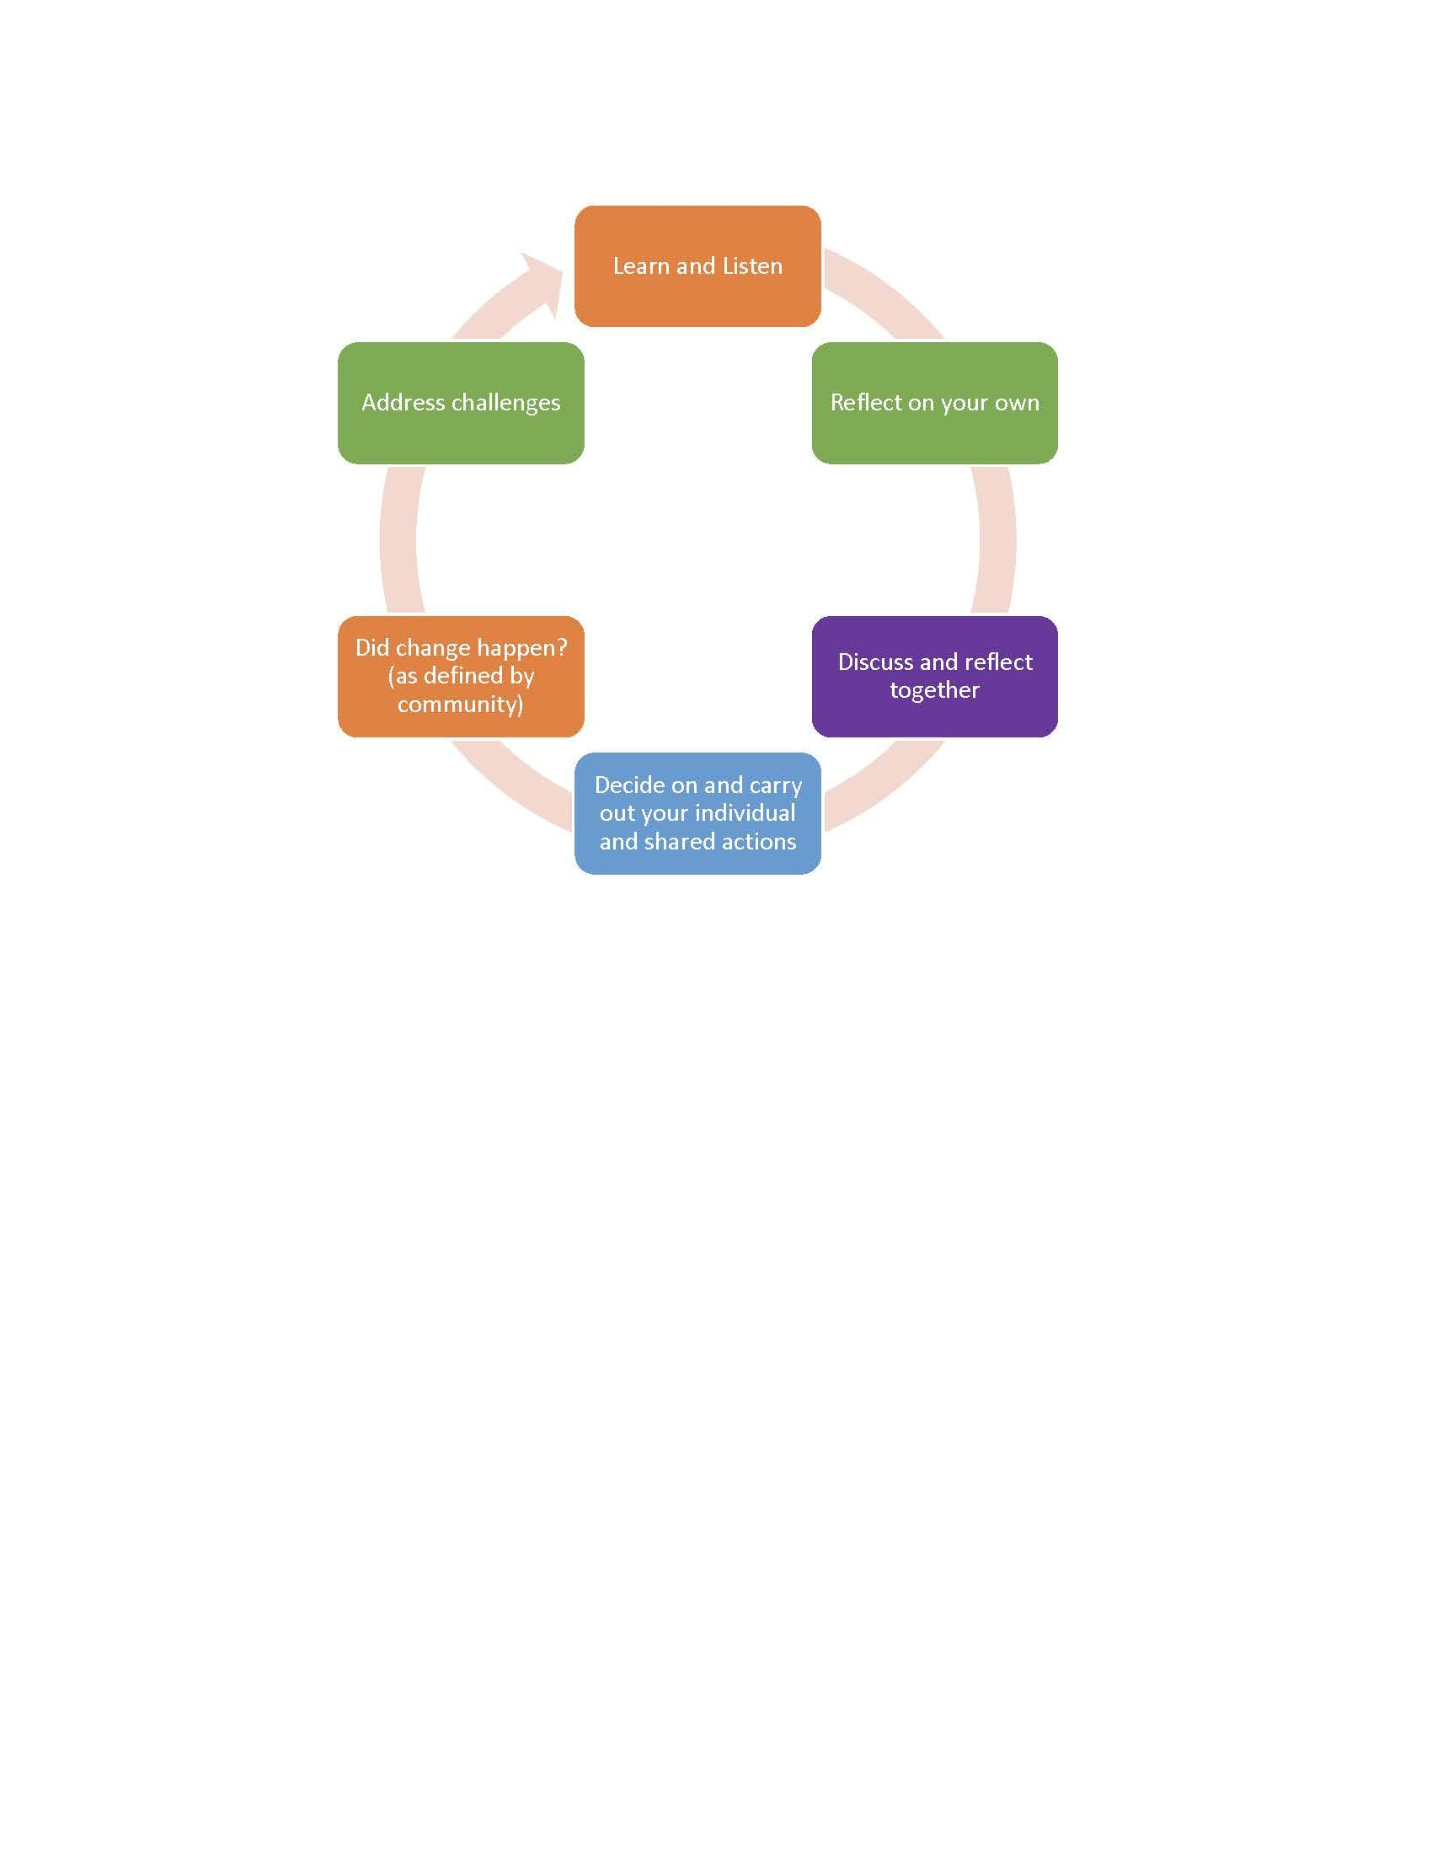

The prompts in this tool are intended to support researchers and community- academic research partnerships who wish to address racial inequities and advance anti-racism in their research practices and processes. There are **12 questions organized into four sections:**

1. **A. Understanding History and Context**
2. **B. Partnership Process and Structure**
3. **C. Research Design and Conduct**
4. **D. Research Dissemination and Impact**

Some elements may be most appropriate for researchers (and/or research teams) and community partners to learn and reflect about on their own. Other pieces may be important to discuss collaboratively with both community and academic partners. Some prompts may be particularly important for non-BIPOC researchers collaborating with BIPOC communities. These are not easy or simple or one-time conversations or reflections or actions. Being open to admitting we don’t have all the answers is a fundamental part to socializing the fact that this is long-term work and quite messy. Discomfort with self-reflection and having these conversations should not be valued over understanding the impact of the inequities. It can feel difficult to address issues that show up in research, but are also operating in broader inequitable systems and structures. This tool suggests concepts that partners can learn about, questions that partners can wrestle with, and steps that partners and partnerships can take that are within their own decision-making control including **advocacy** for changes in broader systems or policies that are outside of their control. To support racial equity in research engagement, self and shared reflection and learning are important but not enough. Action and change must follow. Are you staying comfortable? Are you keeping others comfortable? How are you challenging yourself and others?



**Resources**: Click on these links for [**Guidance for Developing Your Community- Engaged Research Anti-Racist Action Plan**](https://docs.google.com/document/d/1W2E9KIlYREessMvY5IfwCxH6Sj0RmGPYhnvR0cntk2U/edit), [**one-page summary**](https://drive.google.com/file/d/1rHatC9CK4geFe69J2aAaDBkxNjSSL8u9/view?usp=sharing) **of this tool**, and list of relevant references and resources in the [**ARCC Racial Equity in Research Engagement: Resource Catalog**](http://bit.ly/ARCCequityResources).

## **Key Terms**

* **Anti-Racism**is the active process of identifying, challenging, and changing the values, structures, and behaviors that perpetuate systemic racism.
* **Black, Indigenous, and (Other) People of Color** (BIPOC) or other marginalized communities is the term used in this tool to address communities most impacted by structural racism and the root causes of health inequities.
* **Community-Engaged Research** is an approach to research that honors & centers the expertise of communities as local, cultural, practice, lived experience experts in collaboration with academics with scientific expertise to increase the value of research for improving health & equity.
* **Health equity** means that everyone has a fair and just opportunity to be as healthy as possible. A health equity focus intentionally addresses on those most experiencing inequities and removing obstacles to health such as poverty and discrimination.
* **Power** is the ability to define, set, or change situations. It can manifest as personal or collective self-determination, and is defined by the ability to influence others to believe, behave, or adopt desired values.
* **Racial equity** is the condition that would be achieved if one's racial identity no longer factored into health and wellbeing. Racial equity is inclusive of gender, class, ability, and sexuality.
* **Racism**, as defined by Camara Jones, MD, MPH, PhD, is a system of structuring opportunity, which assigns value based on race, disadvantaging People of Color while offering advantage to White people, hindering the realization of the full potential of the whole society through the waste of human resources.

**Resources**: [Advancing Health Equity: A Guide to Language, Narrative & Concepts](https://www.ama-assn.org/about/ama-center-health-equity/advancing-health-equity-guide-language-narrative-and-concepts-0), [Health Equity Guiding Principles for Inclusive Communication](https://www.cdc.gov/healthcommunication/Health_Equity.html), & [Advancing Public Narrative for Health Equity & Social Justice](http://publichealth.lacounty.gov/CenterForHealthEquity/PDF/advancing%20public%20narrative%20for%20health%20equity%20and%20social%20justice_NACCHO.pdf).

# Section A: Understanding History and Context

Research partnerships and projects do not start with a blank slate. It is important to understand the historical and current community context related to research and relationships with academic and health institutions generally, as well as the history and legacy related to specific health issues and medical and health professions.

1. **How can researchers learn about communities *before* partnering in research**?

It is a sign of respect to learn about this history and context and to not put the burden of educating researchers about these things on community partners. Researchers always conduct an academic literature review at the outset of a research project and also need to conduct a ‘community review.’ This learning may include spending time in the community, listening, bearing witness, and exploring:

* Who are the communities, people, and stakeholders that are positively or negatively impacted by your research?
* What is the history, geography, politics, and cultures of the community(ies)?
* Who are the key leaders and stakeholder institutions in the community(ies)?
* What past and current experiences have the community(ies) had with research and research institutions?
* What past and current community programs and services are related to your research focus?
* How can you support this community learning for members of your research team and partnership? 

How can you **advocate** for including this type of community learning in academic and health professions’ education and training programs? What examples of this type of learning in other fields can you borrow from? How can you advocate for university leaders to spend time in local communities listening and learning?



[ARCC resource](https://docs.google.com/presentation/d/1L5IxljF1KQFlDfMafW2ibgJHgjkN8J5betrKME5vhqw/edit?usp=sharing) to support academic researchers to learn about communities before and during community engagement.

Learning more deeply about communities may also be important for larger community organizations and public agencies who may be more disconnected from community members with lived experience and those most impacted by inequities.

1. **How can researchers and community partners develop your own understanding of equity and racism concepts?**

This may include individual and collaborative learning, reflection, and asking yourselves:

* How do you define your own positionality, identities, and lived experience?
* What does your privilege(s) look like? How do you benefit from current systemic inequities?
* What are your own biases (including implicit)?
* How do you receive and respond to feedback, especially about your missteps?
* What is the relevant history and legacy of racial injustice in your institution or organization that may impact community participation and trustworthiness of researchers or research projects or partnerships?
* What is the relevant history of racial injustice in local or national research projects? 

How can you **advocate** for including this type of self-reflective learning in academic and health professions’ education and training programs, as well as staff and leadership at universities, funders, journals, and professional associations?

1. **How can your partnership develop a *shared* understanding of equity & racism concepts and how they apply to your collaboration?**

Ask yourselves:

* Could your partnership benefit from collaborative discussion of questions 1 and 2?
* Would your partnership welcome racial equity training and capacity building? E.g. effective bystander intervention techniques for addressing issues of inequity, harassment, and discrimination.
* Would your partnership support the development of safe and brave spaces for BIPOC to organize and discuss issues surrounding race/racism in the absence of White people?

Does the academic institution or community organizations that you represent support reflection around anti-racism, and strategies to operationalize racial equity? What are ways your partnership may **advocate** for changes in your organization or institution to mitigate or address ways your institutions or organizations are addressing or contributing to racial inequities?

# Section B: Partnership Process and Structure

1. **How can your partnership meaningfully engage communities and people most impacted by inequities**?

This requires partnerships to collaboratively develop a deep and shared understanding of the community-engaged research approach-- engagement in all phases of the research process from formulation of question(s) to dissemination of and taking action based on findings-- and how that engagement and collaboration will be tangibly operationalized throughout the partnership’s leadership and structure, policies, and practice. Ask how your partnership can:

* Prioritize representation of BIPOC and other marginalized communities in partnership governance and research team formation (including hiring as faculty, staff, consultants, students/interns). Consider ways to address potential racism and other issues of bias that BIPOC researchers and community partners may face in predominantly White academic institutions and settings and create a safe working environment for people to bring up racist incidents.
* Provide racial equity capacity building of existing and new research team members (including administrators) and community partners.
* Develop ongoing mechanisms for engaging and supporting community members (people with lived experience, not only professional representatives from community organizations or public agencies) in partnership governance and holding the partnership accountable to community members and stakeholders that are not directly part of the partnership. Also consider representation of who is engaged at community organizations (researchers often engage primarily with leadership that may be more likely to be White versus frontline staff which may be primarily BIPOC).
* Adopt deliberate plans for developing the capacity and leadership of BIPOC and community members most impacted by inequities within the partnership, as future research staff and faculty, and with local or national entities. This includes nominations for awards, fellowships, and other opportunities and considering supportive mentoring practices for BIPOC team members when research/institutional leads are White.
* Cite and center relevant scholarship of BIPOC researchers in your grant proposals and publications.

**Advocate** for inclusion and support of BIPOC, people with lived experience, and other community stakeholders in decision-making bodies at health and research institutions, research funders, journals, and professional associations, and as speakers and writers in conferences, lectures, articles, etc. that those groups organize. **Advocate** for targeted retention and inclusion initiatives at the academic department or university level, such as a cohort or cluster approach to diversifying faculty, staff, and students/interns. 

1. **How can your partnership adopt processes that support transparent communication and shared power?**

Ask how your partnership can:

* Evaluate decision-making power and process in the partnership
* Adopt intentional mechanisms to validate community expertise and support and center community leadership
* Make space for frank and ongoing communication about equity issues such as inequitable compensation between academic and community partners and inequitable levels of institutional and organizational infrastructure (e.g university indirect rates)
* Anticipate and address how to handle racist incidents in the partnership or research
* Anticipate and address how to handle research behaviors and activities which may result in harm or do not benefit the community(ies)
* Identify and evaluate measures of partnership equity, diversity, and inclusion
* Plan for the time and resources needed to appropriately adopt and practice transparent communication and shared decision-making
* Allocate time and resources to support healing, joy, and thriving for BIPOC and other marginalized researchers and community partners in your partnership

Raise and **advocate** collaboratively around how these issues above (processes for handling racist incidents, transparency, etc.) can also be discussed at health and research institutions (centers, departments) and with research funders and journals (e.g. as part of review processes). 

1. **How can your partnership adopt practices that support equity and community investment?**

Ask how your partnership can:

* Discuss and agree on shared principles of equity or values and how these are operationalized in your practices and policies.
* Prioritize community partner compensation/support that delivers meaningful participation (e.g. indirect rates for community partners, commute costs beyond parking, realistic levels of compensation (number of hours, % time).
* Purchase catering, trainers, materials, space, etc. from local vendors/organizations owned/led by BIPOC and other marginalized communities.
* Consider impact of source of your partnership’s funding/support (e.g. restrictions or guidelines from private donors or public or private funders)
* Offer paid internships that support interns who may not have privilege to do unpaid work.
* Leverage academic institution resources for community benefit(e.g. access to peer reviewed journal articles, access to university meeting rooms, etc.)

**Advocate** for an increase in anchor institution roles and resources that support equity (e.g. purchasing, hiring, investing from BIPOC communities/businesses) by research and health institutions, professional associations, conferences, etc. 



[ARCC **resources** related to community-engaged research and partnership development and](https://docs.google.com/presentation/d/1L5IxljF1KQFlDfMafW2ibgJHgjkN8J5betrKME5vhqw/edit?usp=sharing) process are available at [www.ARCCresources.net](http://www.arccresources.net).

## **Section C: Research Design & Conduct**

1. **How can your partnership consider how racial inequities impact the health issues and research questions you’re addressing?**

Consider:

* Identifying which BIPOC or other marginalized groups are currently most advantaged and most disadvantaged by the issues this research seeks to address. How are they affected differently? What quantitative and qualitative evidence of inequality exists? What evidence is missing or needed?
* Conducting root causes analysis for historical, structural, and systemic factors related to the health issues and research questions the partnership is addressing. What factors/systems/ structures may be producing and perpetuating racial inequities associated with this issue (instead of focusing on individual-level behavior or characteristics)? How did the inequities arise? Are they expanding or narrowing? Does the research proposal address root causes, systems, structures (instead of individual level changes)? If not, how could it?
* Factors related to community assets/strengths/successes (love, joy, liberation; not just deficits, barriers)

Engage in disciplinary self-critique and **advocate** for responsiveness to these types of research design/conduct issues by research funders, journals, conferences, etc. 

1. **How can your partnership consider equity issues when identifying and engaging research populations?**

Ask how your partnership can:

* Center the lived experience of communities most impacted by inequities to identify research priorities, recruitment strategies, and appropriate incentives
* Conduct research that serves segments of communities most impacted by inequities (e.g. Black Trans women vs. White Cis men) and populations (or segments) that have been historically excluded from research
* Assess who is not being adequately represented and make modifications that lead to adequate representation and/or document challenges (including addressing language justice and digital equity issues)
* Consider how community participants may experience the recruitment, data collection, and related processes (i.e. is it culturally relevant, welcoming, or distancing?)
* Consider issues of intersectionality in data collection and description
* Consider potential racism and other issues of bias and safety for research staff & faculty during participant recruitment and data collection in communities or the ‘field.’ (i.e. how are BIPOC researchers prepared/supported related to potential racism or other safety issues in community settings? how are White researchers prepared to have cultural humility & be anti-racist before going into community settings?)

**Advocate** for consideration of these types of engagement issues by recruitment entities at research institutions and research funders.

1. **How can your partnership prioritize asset-based & solution-focused research designs?**

Ask how your partnership can use:

* Asset-based community assessments (not just focusing on needs or problematizing issues). Ensure processes are in place to learn from community expertise as a foundational activity for your partnership
* Intervention research design or tailor interventions that are accessible, acceptable, effective in, and used by the groups most impacted by inequities
* Intervention designs that will impact root causes and underlying systemic structural drivers of inequity
* Intervention designs that consider what adverse impacts or unintended consequences could result from the intervention. Which BIPOC or other marginalized groups could be negatively affected, and how adverse impacts could be prevented or minimized?
* Intervention designs that consider what positive impacts on equality and inclusion, if any, could result. Which BIPOC or other marginalized groups could benefit? Are there further ways to maximize equitable opportunities and impacts?
* Designs that answer critical questions about the ways in which cultural context is enmeshed with both the structural conditions and the intervention itself.
* Share early learnings so community partners can take action if relevant
* Intervention designs that are financially viable and realistic to sustain beyond research funding if effective

**Advocate** to funders for inclusion of these research designs in their calls for funding and review processes, as well as to journals and conferences.

**10. How can your partnership engage with communities to better understand results?**

Think about:

* Analyzing how and why community interpretations align with or differ from academic researchers’.
* Acknowledging that research interpretations may be driven by implicit bias and should be reviewed by those with lived experience.
* Assessing outcomes to understand who benefited more or less from interventions (including gaps in reach) and if there were any unintended outcomes.
* Collecting qualitative data to better understand racial equity aspects of quantitative findings.
* What racial categories and comparisons are being used in analysis and how racism may be named as a central concept in observed differences (e.g. not attributing effects to *race* when they should be attributed to *racism*).
* Considering the advocacy potential of your partnership’s data and findings. As work is underway, this should be reflected in budget strategy so that community partners can undergo strategic communications training to develop campaign or policy memo materials, can undergo lobbying/formal organizing training, build internal advocacy infrastructure capacity, etc.

**Advocating** to research funders and journals to fiscally support and publish research that includes community stakeholders in research analysis and interpretation.

# Section D: Research Dissemination and Impact

**11. How can your partnership design research communication that is respectful and representative to communities?**

Consider how:

* Research can be a tool for communities to tell their own stories.
* Language justice is being centered to prioritize dissemination language/venues that are accessible and understandable to community partners and members.
* Findings can be communicated in ways that provide relevant context of root causes and structural and systemic factors.
* Prioritizing spokespersons and authors and partners that can represent the community.
* Ensuring images and language don’t perpetuate stereotypes and dehumanize community members

**Advocate** to research funders, journals, and conferences to include community stakeholders in ensuring that research findings and dissemination are respectful, representative, and accessible to communities.



**Resources**: Urban Institute’s [Do No Harm Project](https://www.urban.org/projects/do-no-harm-project) materials focused on equity in data analysis and visualization.

**12. How can your partnership support and evaluate the impact and value of the research to communities (as defined by communities)?**

Preferably before the research has begun, set the partnership tasks of:

* Identifying clear markers of short and long term success as defined by communities.
* Ensuring mechanisms are in place to support successful implementation and sustainability of interventions.
* Ensuring access to research data and findings that would support community advocacy and decision-making. There is a particular need to think intentionally about a sustainability plan for research data access by community partners, particularly if the data is not archived by the source, or readily accessible beyond a certain time period.
* Tracking intentional and unintentional impacts of the research.
* Developing processes for communities to express grievances or satisfaction and consequences or accountability mechanisms if community goals are not met or harm is caused.

**Advocate** to research institutions, funders, journals that metrics of success for faculty and research should include those that are defined and measured by communities.

## **Background & Acknowledgements**

ARCC is working to further our understanding of racism and bias in research and community engagement and support community-academic partnerships to address racial equity issues in research and the partnerships themselves.This tool was developed through extensive conversations, reading, and reflection among ARCC community and academic partners and staff. The work was supported in part by 2019 and 2020 Northwestern University [Daniel I. Linzer Grants for Innovation in Diversity and Equity](https://www.northwestern.edu/provost/faculty-honors/diversity-and-equity-grants/about.html), the [Chicago United for Equity](https://www.chicagounitedforequity.org/) [2019 Racial Equity Fellowship](https://www.chicagounitedforequity.org/2019-fellows), leadership from the [Equity Institute](https://www.ywca-ens.org/equity-institute/) at [YWCA-Evanston/Northshore](https://www.ywca-ens.org/) and participants in ARCC’s 2020-21 [Community-Academic Anti-Racism Learning Collaborative](https://docs.google.com/document/d/1JRvawNsrBZTSrkD-cCYSY2v8LrVGBOAihzlfTsI50Ik/edit?usp=sharing), and collaboration with [Chicago Beyond](https://chicagobeyond.org/) and their guidebook, [Why Am I Always Being Researched?](https://chicagobeyond.org/researchequity/)

### ARCC Background

Established in 2008, the [**Alliance for Research in Chicagoland Communities**](https://www.feinberg.northwestern.edu/sites/cch/get-support/arcc/index.html) (ARCC) supports authentic community-academic research partnerships between Chicagoland communities and Northwestern University that benefit the people being researched and improve health and equity. ARCC advocates for a collaborative approach to research that honors, is driven by, and shares power with communities, as local, cultural, and lived experience experts. Guided by a S[teering Committee](https://docs.google.com/document/d/1IwkulX45ve7QiT9yAdlnIjJpiDtB5ttTSsdA0atrPLs/edit) of thirteen Chicagoland community- and faith-based organizations, two public agencies and eleven Northwestern scientists, ARCC supports community-academic research partnerships by providing partnership facilitation, capacity-building [resources](http://www.arccresources.net) and [technical assistance](https://www.feinberg.northwestern.edu/sites/cch/get-support/consultation-support-and-sharps/index.html), [seed grants](https://www.feinberg.northwestern.edu/sites/cch/get-support/arcc/arcc-seed-grants.html), [monthly information and resource update](https://www.feinberg.northwestern.edu/sites/cch/news/index.html)s, and advocacy for supportive structural and institutional systems and policies in the research enterprise. ARCC is a program of the [Center for Community Health](http://www.feinberg.northwestern.edu/sites/cch/) serving Northwestern’s Institute for Public Health and Medicine ([IPHAM](https://www.feinberg.northwestern.edu/sites/ipham/)) and the Northwestern University Clinical and Translational Science ([NUCATS](https://www.nucats.northwestern.edu/)) Institute. We strive to uphold the [**CCH Principles of Engagement**](https://www.feinberg.northwestern.edu/sites/cch/about/principles-of-engagement.html) in our approach and the research we support.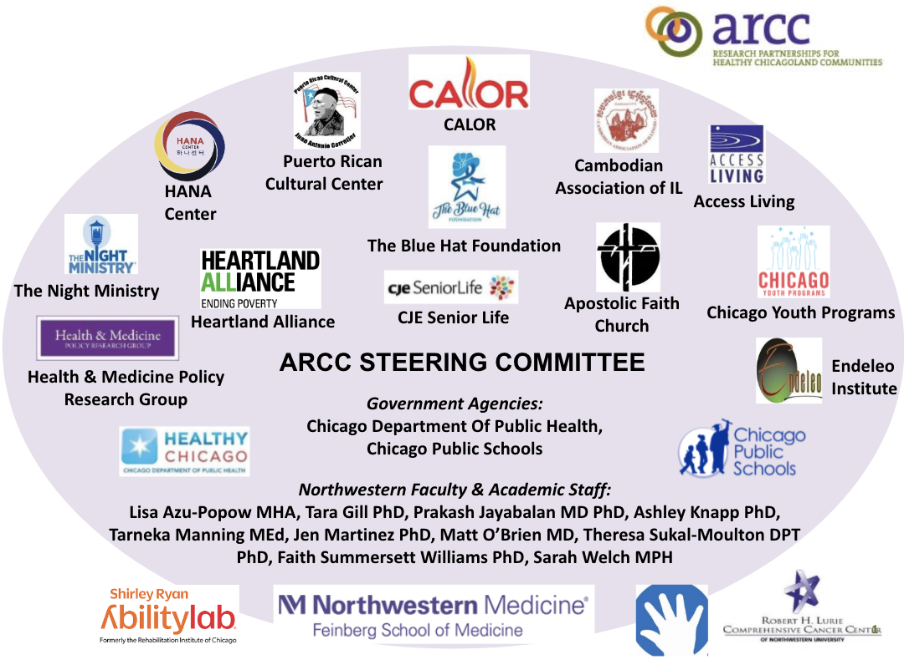

ARCC’s Anti-Racism Taskforce members include Angel Miles (Access Living), Karou Wantanabe (Cambodian Association of IL), Inger Burnett-Zeigler (Psychiatry, Northwestern), Tara Gill (Child & Adolescent Psychiatry, Northwestern/Lurie Children’s), Jen Martinez (Psychiatry, Northwestern), Tiffany McDowell (Equity Institute), Eileen Heineman (Equity Institute), Ariel Thomas (ARCC), Jen Brown (ARCC), Shehara Waas (ARCC). Previous members include Gregory Gross (The Night Ministry), Anthony Guerrero & Kevin Hernandez (Puerto Rican Cultural Center), Prakash Jayabalan (Physical Medicine & Rehabilitation, Northwestern/AbilityLab), and Rebecca Johnson (formerly with Northwestern/ARCC).

*Citation*: Alliance for Research in Chicagoland Communities. (2021) Anti-Racist Community-Academic Research Reflective Practice Tool for Researchers and Partnerships. Available at [www.ARCConline.net](http://www.arcconline.net).